# Deploy MongoDB RHEL Ec2 instance

## Login to EC2 instance server

## Create a file /etc/yum.repos.d/mongodb-org-5.0.repo

And write :

| [mongodb-org-5.0] |
| --- |
| name=MongoDB Repository |
| baseurl=https://repo.mongodb.org/yum/redhat/$releasever/mongodb-org/5.0/x86_64/ |
| gpgcheck=1 |
| enabled=1 |
| gpgkey=<https://www.mongodb.org/static/pgp/server-5.0.asc>  Save the file |

## Install MongoDB :

Using the command :

sudo yum install -y mongodb-org

## Change the /etc/mongod.conf

The bind_address should be

bind_address= 0.0.0.0

## Start the service:

sudo systemctl start mongod

## Check the status:

sudo systemctl status mongod

# Install Mongodb on local machine :

## Download MongoDB Community Server

From here:

https://www.mongodb.com/try/download/community

Check the connection using IPs:

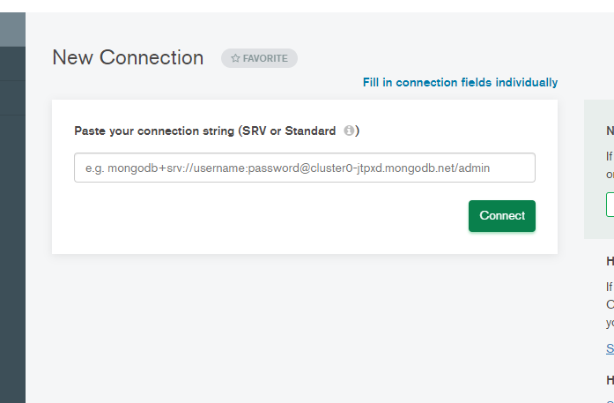

Mongodb paste ec2 instance IPV4 address.

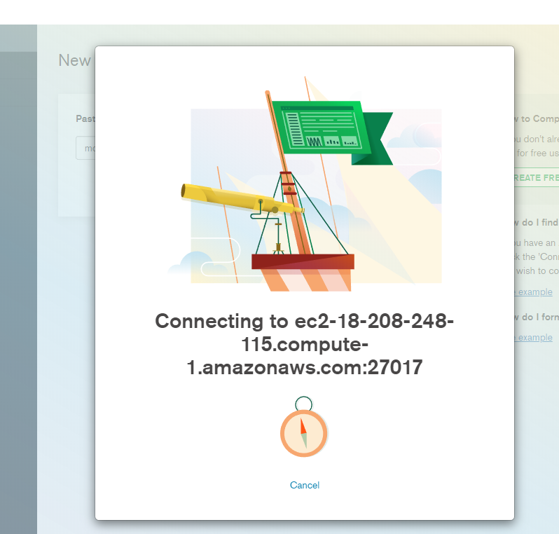

You should be connected to the database

